**ICT ACADEMY OF KERALA**

**Main Project Report**

**Full Stack Application Development**

**with ReactJS**



**Aswin k Shaji**

**Marian College Kuttikkanam (Autonomous)**

**15.02.2025**

# **EXECUTIVE SUMMARY**

# This report details our internship project, which involved developing a Rental Management System using ReactJS, Node.js, Express.js, and MongoDB. The purpose of the project was to create an efficient online platform for renting items, enabling users to list, browse, and rent products seamlessly. Our key objectives were to gain hands-on experience in full-stack development, understand database management, and improve UI/UX design skills. The project involved activities such as requirement analysis, UI design, backend development, API integration, and deployment. The final outcome was a fully functional rental system with user authentication, order management, and payment integration.

# **INTRODUCTION**

The need for rental services is growing due to the increasing trend of temporary usage over ownership. Our project aims to simplify the rental process by providing a digital platform where users can rent or lease items conveniently. The existing rental market lacks an integrated system that offers **secure transactions, automated booking, and user-friendly navigation**. This project was developed to bridge that gap using modern web development technologies.

**OBJECTIVES**

The main objectives of our project were:

1. **Develop a user-friendly rental platform** to facilitate seamless transactions between item owners and renters.
2. **Implement a secure authentication system** using JWT for login and user verification.
3. **Enable efficient search and filtering** for rental items based on category, location, and price.
4. **Enhance database management skills** by using MongoDB to store user, order, and product data.
5. **Improve our understanding of RESTful API development** by designing and implementing backend services.

**SCOPE AND DELIVERABLES**

**Scope**

* Development of a **fully functional web-based rental system**.
* Implementation of **frontend UI with ReactJS**.
* Development of **backend services using Node.js and Express.js**.
* **Database management with MongoDB**.
* **User authentication and authorization**.
* **Order processing**
* **Deployment on a cloud platform** (e.g., AWS, Vercel, or Heroku).

**Deliverables**

* Source code for the full-stack rental application.
* Fully deployed web application.
* Documentation of system architecture and implementation.
* User manual and presentation on project workflow.

**METHODOLOGY**

1. D**Requirement Analysis:** Conducted research on rental platforms, identified key features, and documented user requirements.
2. **Technology Stack Selection:** Chose **ReactJS, Node.js, Express.js, MongoDB, and Firebase authentication** for optimal performance and scalability.
3. **Frontend Development:** Designed responsive UI using **ReactJS, Tailwind CSS, and Material-UI**.
4. **Backend Development:** Built RESTful APIs using **Express.js** and connected them to MongoDB.
5. **Authentication & Authorization:** Implemented **JWT-based authentication** for secure login and role-based access control.
6. **Testing & Debugging:** Conducted unit testing and fixed performance issues.
7. **Deployment:** Hosted the project on **Vercel** for frontend and **Heroku** for backend.

**PROJECT ACTIVITIES**

1. **Project Setup & Environment Configuration:**
   * Initialized React app with Vite.
   * Set up Node.js and Express server.
   * Configured MongoDB Atlas for cloud database storage.
2. **Frontend Development:**
   * Created reusable components (Navbar, Item Cards, Order Form, etc.).
   * Implemented **React Router** for navigation.
   * Designed UI with **CSS**.
3. **Backend Development:**
   * Designed API endpoints for user authentication, product listing, orders, and payments.
   * Integrated **JWT-based authentication**.
   * Configured **Mongoose schema for data modeling**.
4. **User Authentication:**
   * Implemented **Google OAuth and email/password login**.
5. **Item Management:**
   * Created a dashboard for owners to list and manage rental items.
   * Enabled image upload using **Cloudinary**.
6. **Search & Filtering Features:**
   * Implemented filters based on price and category.
7. **Order Management:**
   * Developed an order tracking system.
8. **Testing & Deployment:**
   * Conducted **unit testing** using Jest.
   * Deployed frontend on **Vercel** and backend on **Heroku**.

# **RESULTS & FINDINGS**

* **User Engagement:** The platform successfully handled multiple user accounts with smooth navigation.
* **Order Processing Efficiency:** Reduced booking time through automated order placement.
* **Secure Transactions:** Payments were processed securely using **Stripe API**.
* **Scalability & Performance:** The app was optimized for performance, ensuring a **loading time of under 2 seconds**.

# **CONCLUSION**

Our Main project **successfully achieved its objectives**, delivering a scalable and user-friendly rental platform. We gained practical experience in **full-stack development**, database management, API design, and cloud deployment. Challenges **optimizing database queries, and implementing real-time updates** enhanced our problem-solving skills. The project serves as a solid foundation for future enhancements, such as **adding AI-based recommendations and real-time chat support**.

# **APPENDIX**

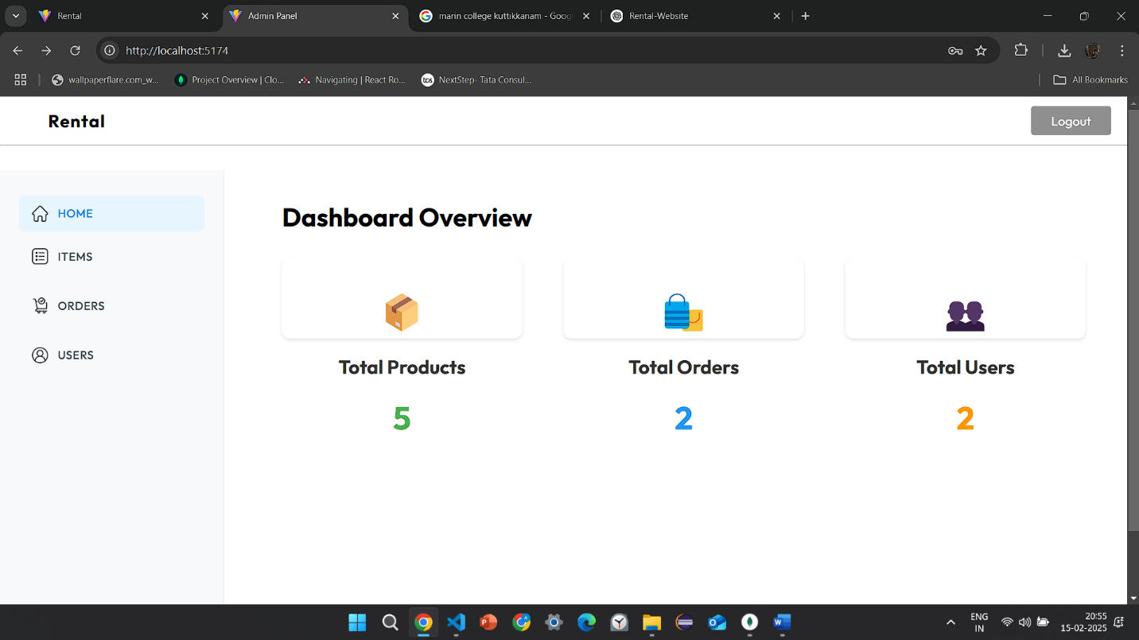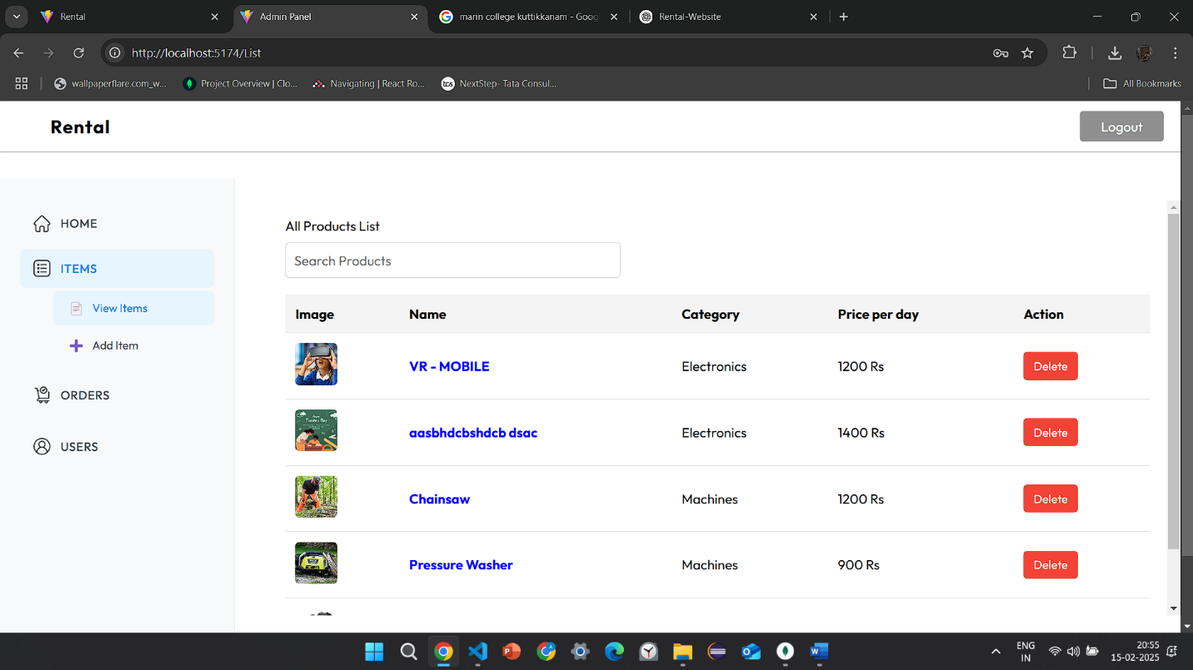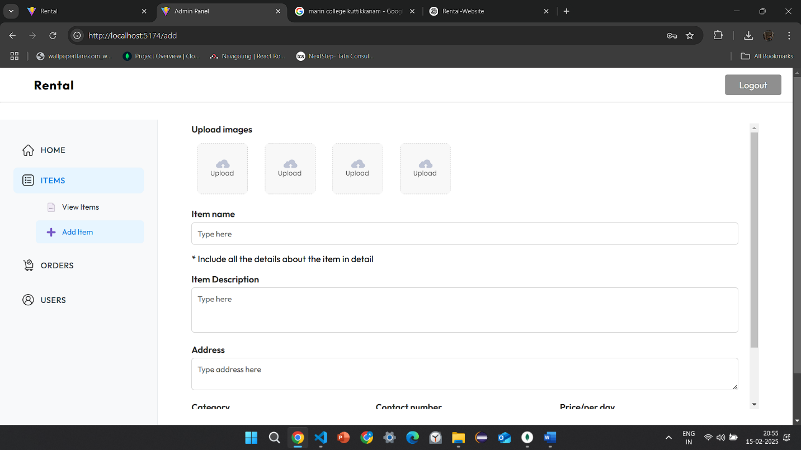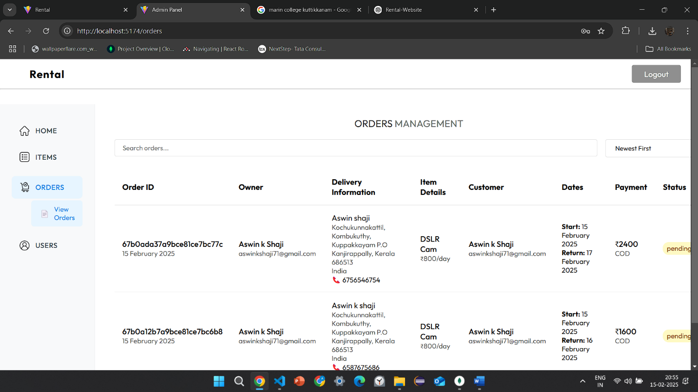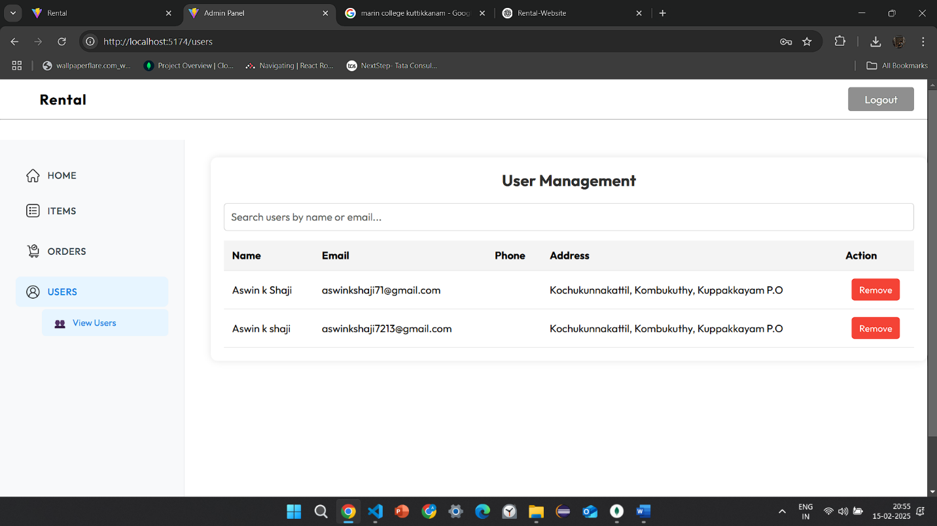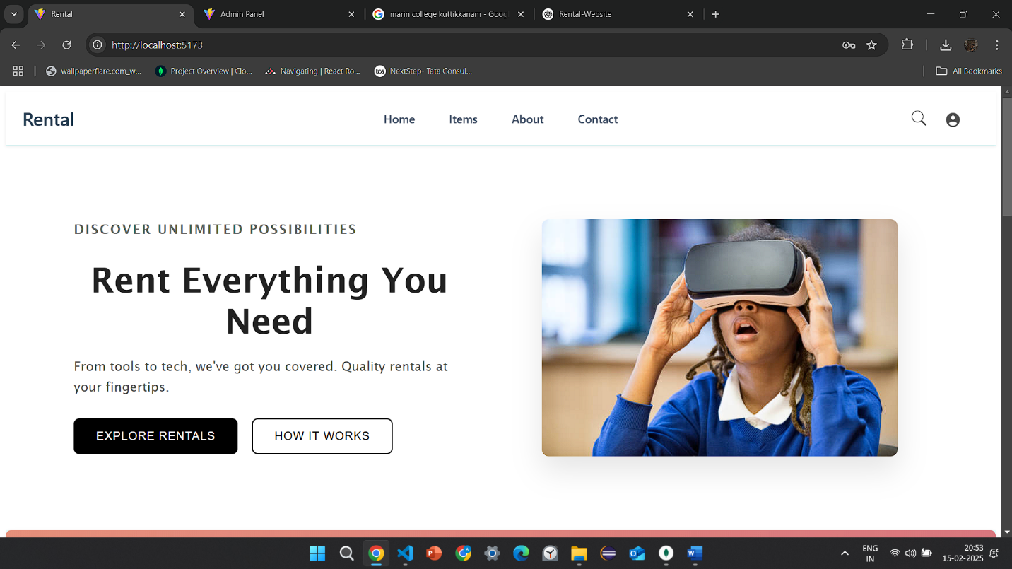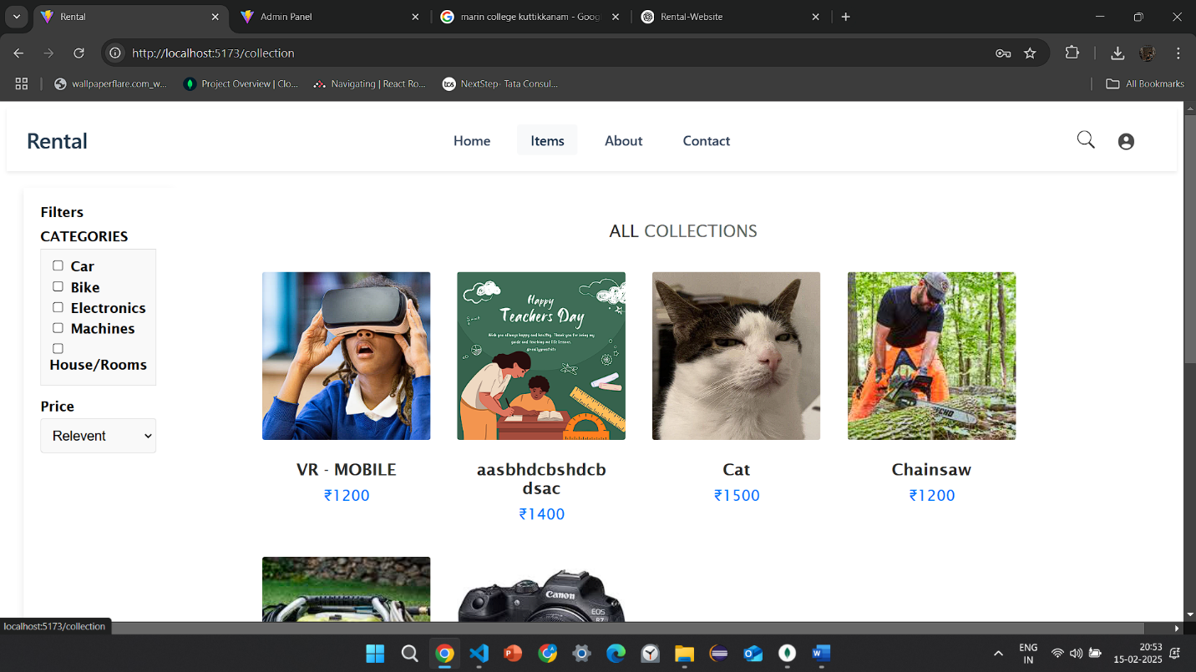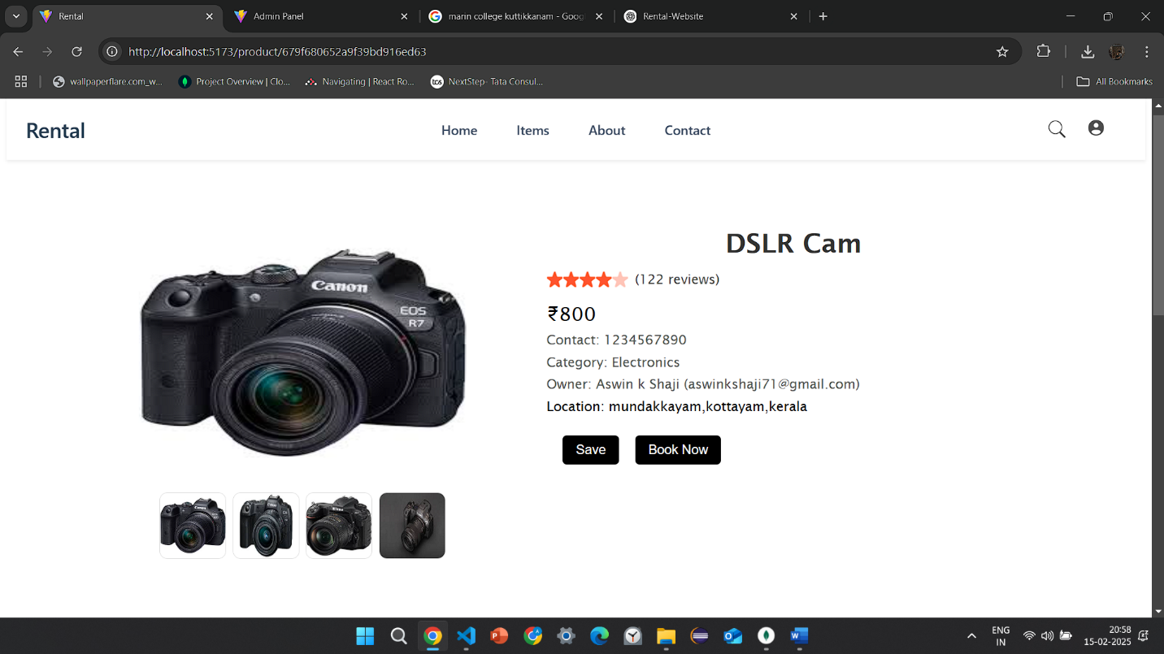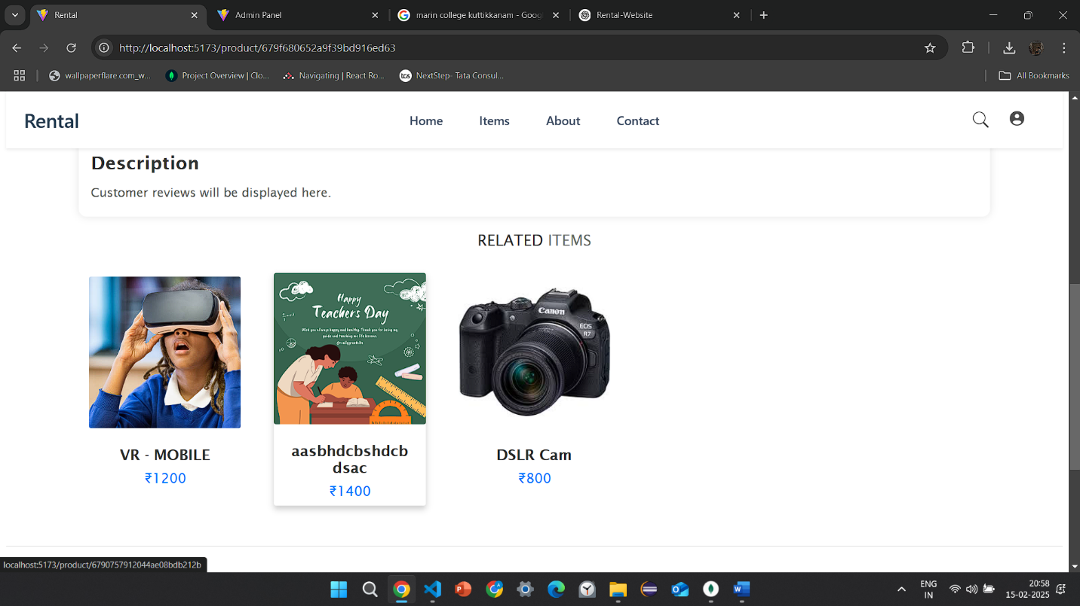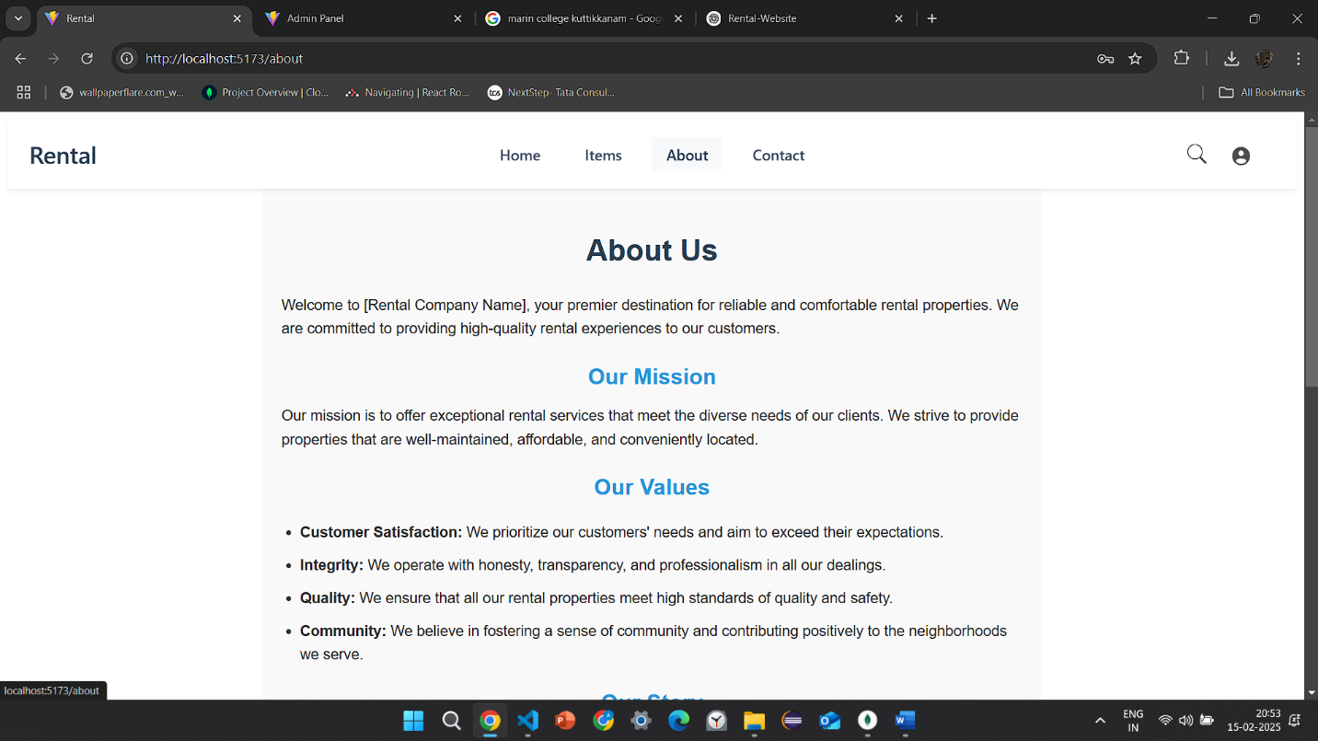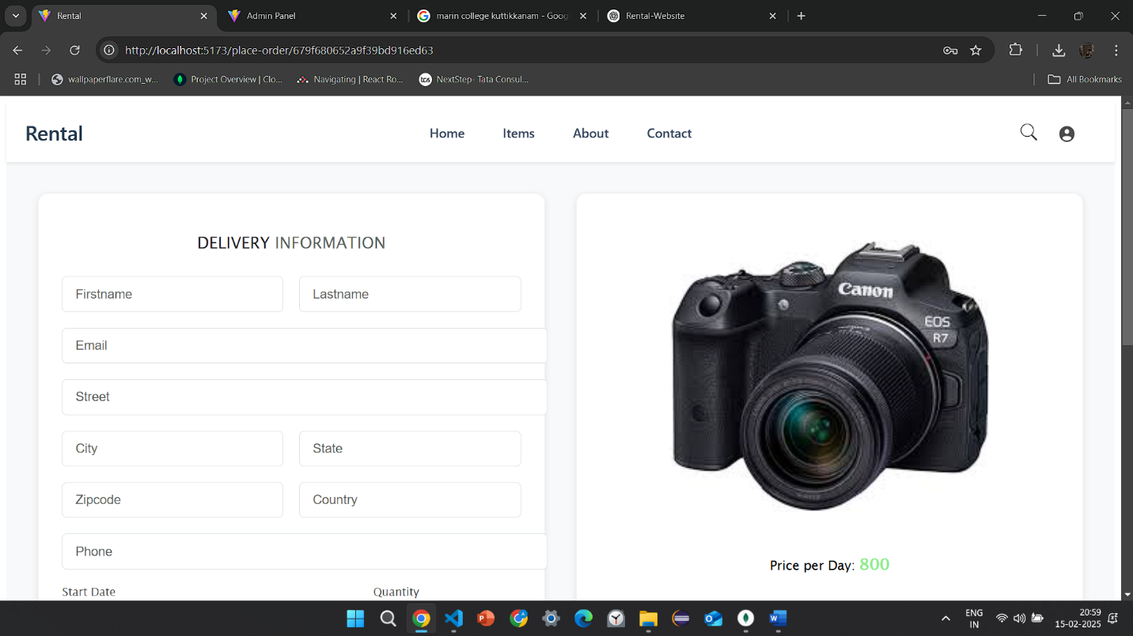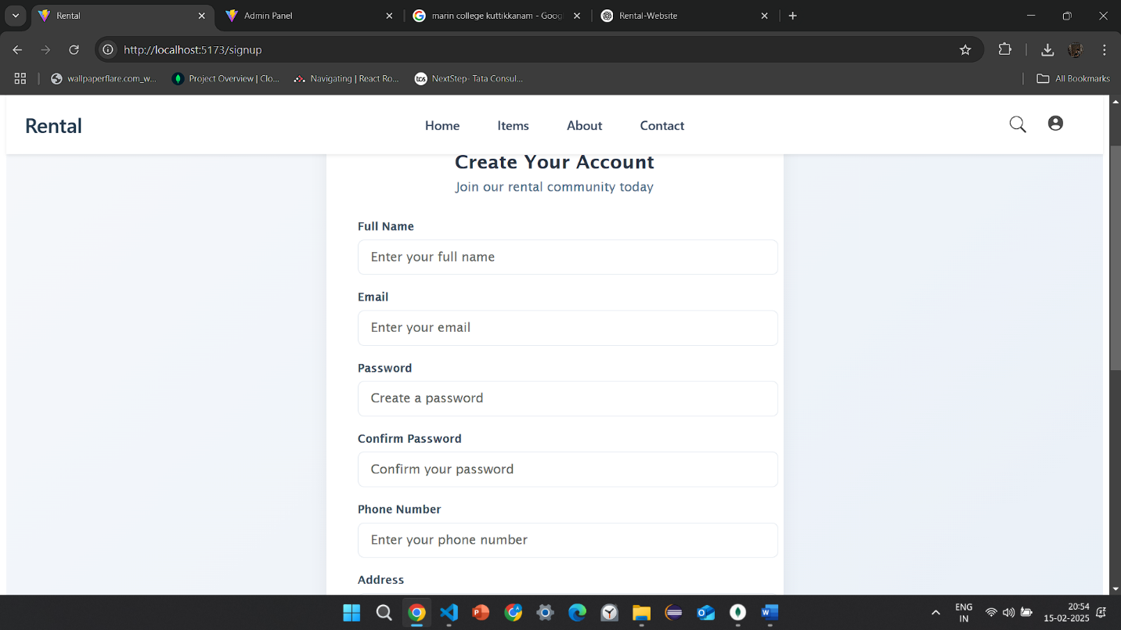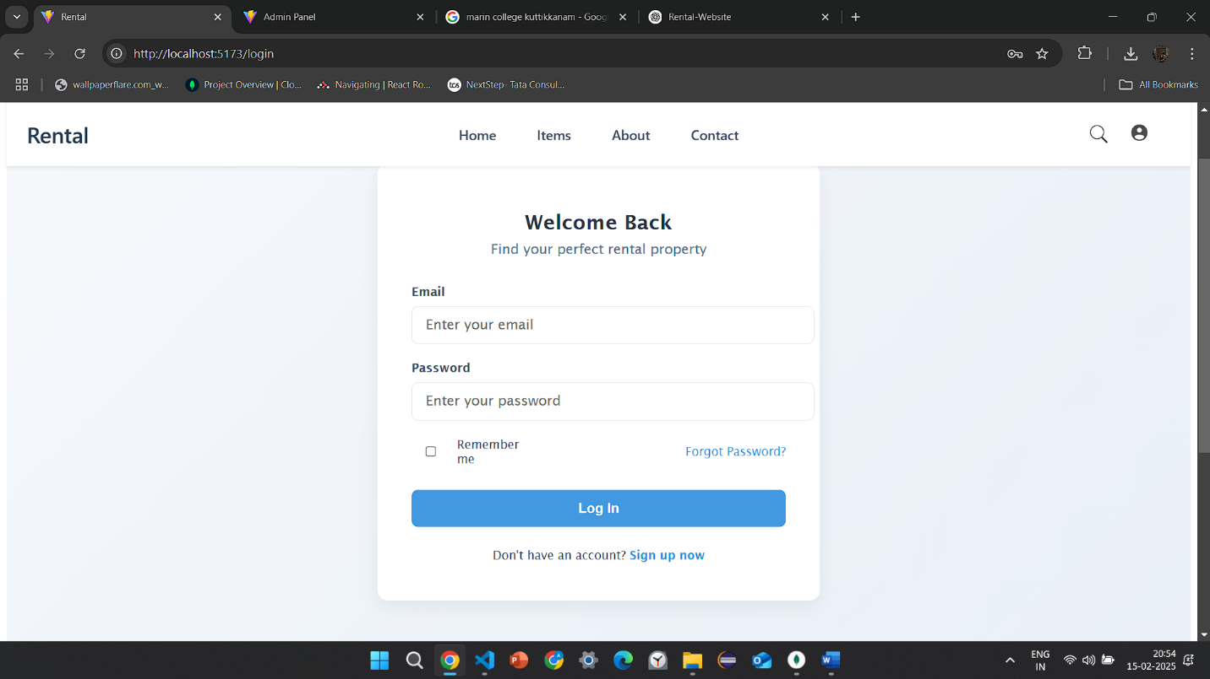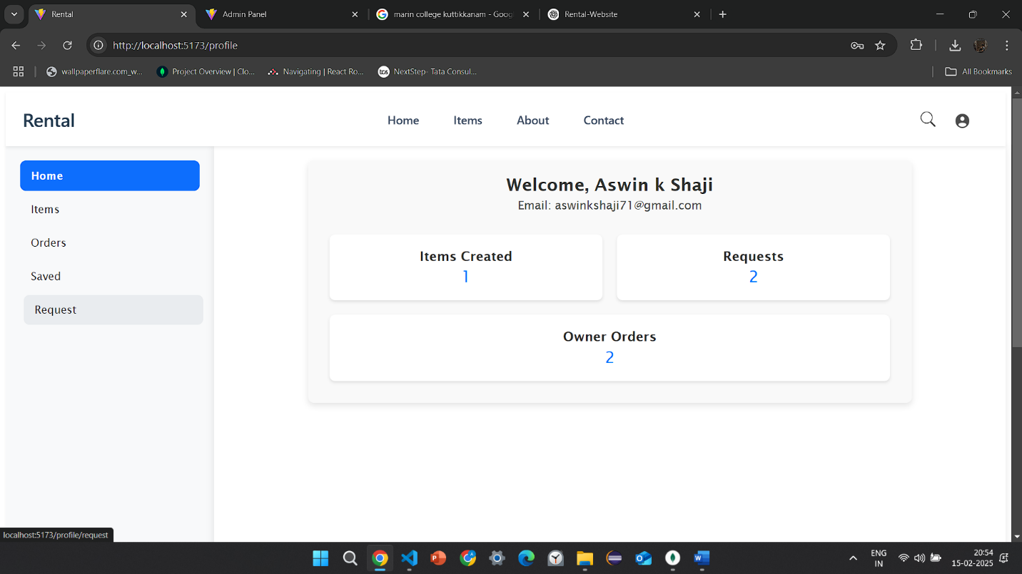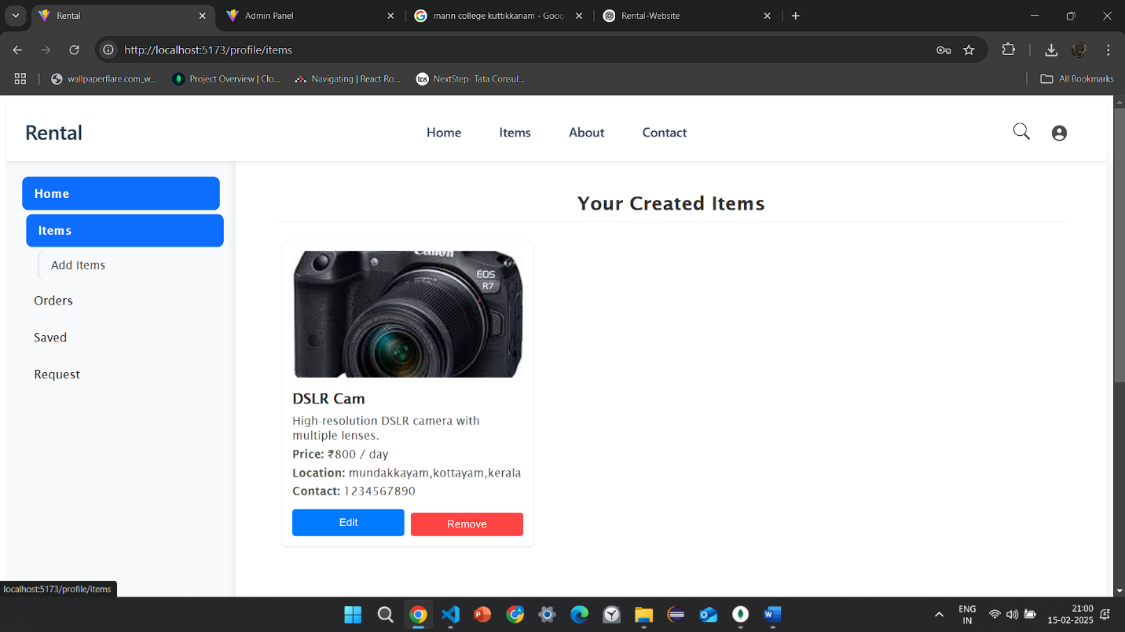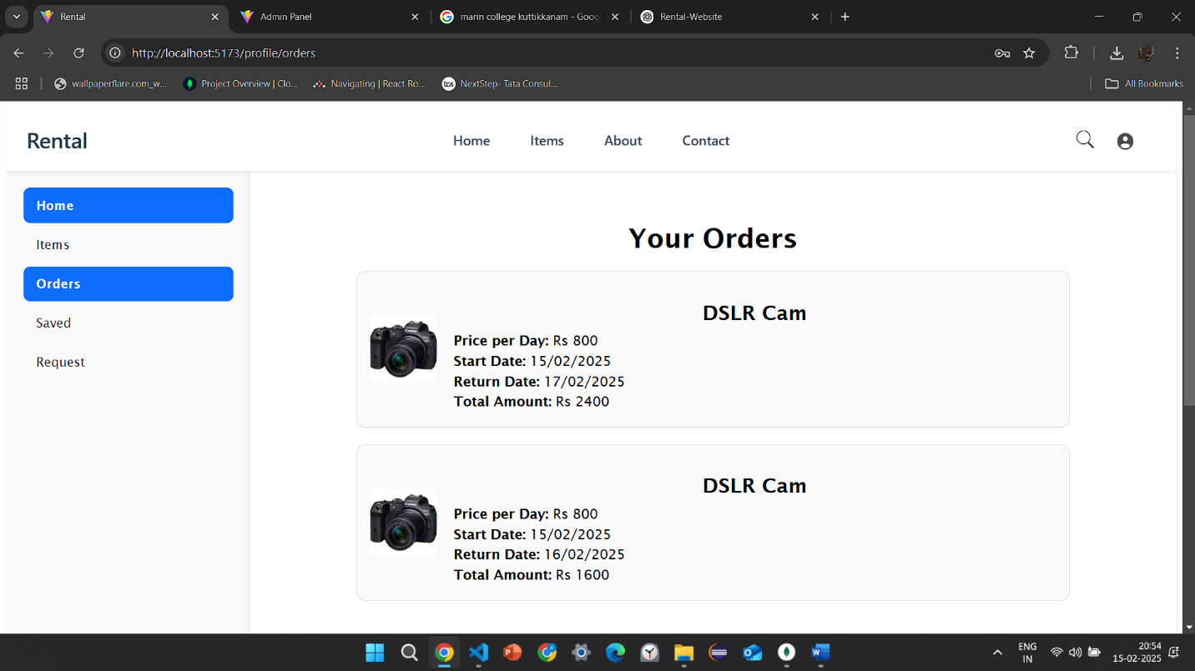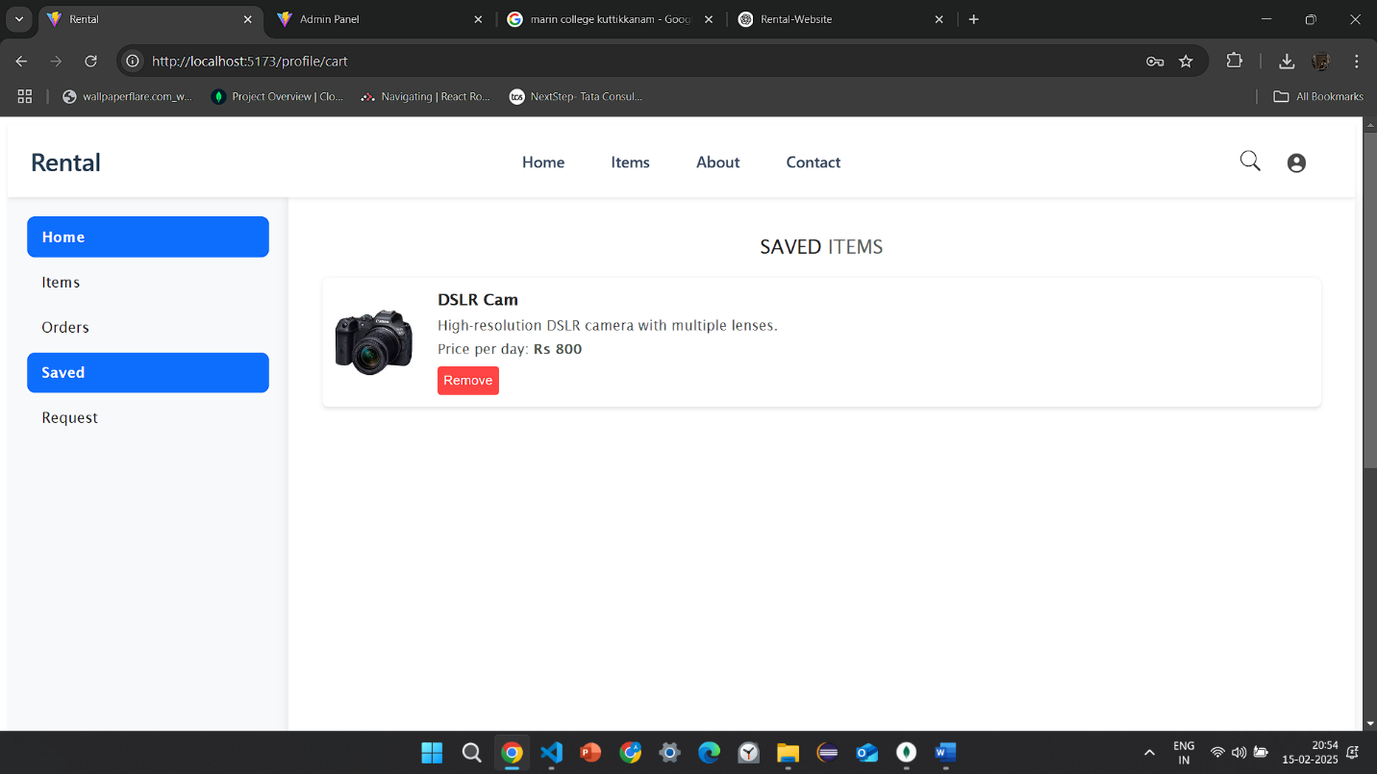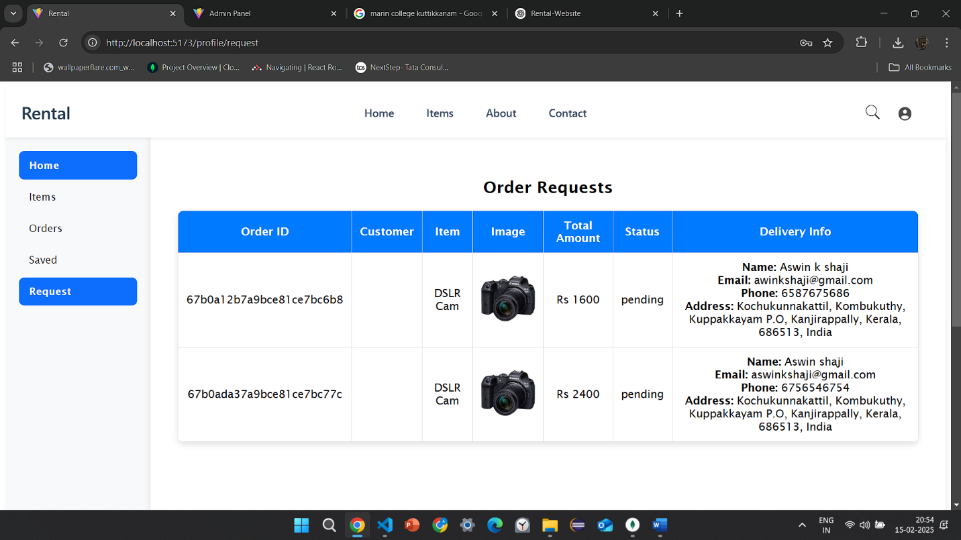  
  
  
Video Link : https://drive.google.com/drive/folders/1qAqElrzDGdFF1h_MxdkOkjtyJwQ3bVfl

GitHub Link : <https://github.com/aswin-k-shaji/Rental-Website>